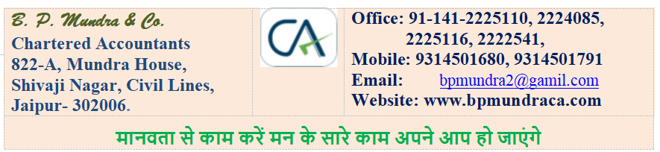
Email Draft - DPT-3 Requirement
Subject: Information Required for Filing Form DPT-3 with MCA/ROC
Dear Sir/Madam,
Since your group is owner/promoter of Private Limited Company / Limited Company, this email is relevant for you. Kindly please note that Form DPT-3 is required to be examined and filed with MCA/ROC, wherever applicable, for reporting deposits and outstanding receipt of money/loan not treated as deposits as on 31.03.2026.
As per MCA General Circular No. 02/2026 dated 19.06.2026, Form DPT-3 for FY 2025-26 can be filed up to 31.07.2026 without additional fees. After receiving the data from your end, we need to examine the ledgers, classify the balances and prepare the form. This will take minimum 5 days. Therefore, to avoid last-minute rush and incorrect filing in hurry, please send complete data positively on or before 10.07.2026.
1. Documents / Data Required
• 1. Tally data in pen drive, complete up to 31.03.2026.
• 2. Copy of previous year Form DPT-3, if available.
• 3. Party-wise ledgers and balance confirmations, wherever available.
• 4. Details of interest paid/provided and TDS deducted, if applicable.
• 5. Director declaration, wherever loan is received from director, confirming that amount is given from own funds and not from borrowed funds.
2. Details Required for Each Applicable Loan / Advance / Deposit / Outstanding Money
Please provide party-wise details in the following simple format wherever any amount is received or outstanding as on 31.03.2026:
Party / Bank Name | Opening Balance | Received During Year | Repaid / Adjusted | Closing Balance
Ageing: <= 1 Year | Ageing: >1 to <3 Years | Ageing: >3 Years | Interest / TDS, if any | Nature / Remarks
3. Please Confirm Whether Any Amount Exists in the Following Categories
1• Foreign or international bank loan/advance - mention bank name.
2• Bank facility: CC, OD, term loan, vehicle loan or any other bank loan.
3• SBI/subsidiary bank, nationalised/notified bank or co-operative bank.
4• SIDBI, RFC, RIICO, NBFC or any regional financial institution.
5• Scheduled bank or other finance company/body corporate.
6• Loan from company, group company, LLP, firm or proprietorship concern.
7• Loan from directors, relatives of directors, shareholders/members or related parties.
8• Customer advance, booking advance, earnest money, trade advance or security deposit.
9• Public deposit/shareholder deposit, renewed/repaid/matured unpaid deposit, if any.
10• Net worth details: paid-up capital, reserves, securities premium, losses, etc.
11• Committee meeting details, penalty, punishment or compounding, if applicable.

4. Why These Details Are Required
These details are required to correctly classify the outstanding balances as deposit / amount not considered as deposit / other reporting item under the Companies Act, 2013 and the Companies (Acceptance of Deposits) Rules, 2014. Correct classification is necessary to avoid wrong or incomplete filing in Form DPT-3.
5. Filing Fees and Charges
MCA filing fees | Rs. 500
Professional charges / expenses | Rs. 3,500
GST @ 18% on Rs. 3,500 | Rs. 630
Total payable | Rs. 4,630
RTGS/NEFT details | A/c No. 11740210000984 | IFSC: UCBA0001174
6. Soft Reminder on Delay
Delay or non-furnishing of data may result in delay/non-filing of Form DPT-3. Filing after the permitted date may attract MCA additional fees ranging from 2 times to 12 times of normal filing fee, depending upon the period of delay. Non-compliance may also attract penalty up to Rs. 5,000 and further Rs. 500 per day for continuing default, wherever applicable. Hence, timely submission of data and charges is requested.
In case the above details have already been sent by you, kindly ignore this email.
Thanks & Regards,
FCA B. P. Mundra
B. P. Mundra & Co.
Chartered Accountants

